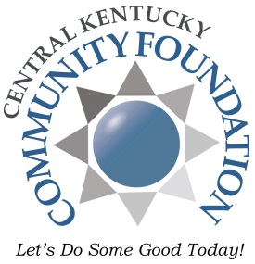
Lahoma Routt
Youth Ministry Scholarship Application

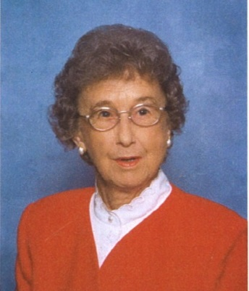
Lahoma Routt spent a lifetime focused on hard work and business. Among the many businesses she and her husband owned and operated was Routt’s Motel and Restaurant, which featured the first buffet restaurant in the region. Mrs. Routt was an accomplished cook who enjoyed interacting with her customers as much as she enjoyed preparing delicious dishes. Her famous Jam Cakes and Pecan Pies made her a local favorite. She enjoyed travelling many places over the years and collecting souvenirs from different locales. From Florida in the winter to Branson, Missouri, her travels helped her with her other interest -- shopping. Some of her travels started literally from her front yard as her husband piloted their own plane from an airstrip in their front yard. Her church, Severns Valley Baptist, and mission work are lifelong passions for Mrs. Routt. She also values education for people so they can pursue their life goals and dreams. Through her generosity, Hardin county youth will benefit forever in two areas that were of special interest to Mrs. Routt: education opportunities for children preschool - 5th grade and scholarships for youth mission trips and church camps.

Please fill out this form completely and submit to your youth minister/church contact by March 15. This application may be handwritten or completed as an electronic document. Fields will expand to accommodate your answers. Typing your name in the signature line will treat your responses as an electronic signature. Upon completion, please return to your youth minister/church contact for their completion and submission to CKCF.

Scholarship recipients will be notified around April 15.

If you have any questions about the application, please contact
Central Kentucky Community Foundation at scholarships@ckcf4people.org or 270-737-8393.

Summer Camp Scholarship Guidelines:
- Applications are accepted from youth at Hardin County protestant churches to attend a church-sponsored camp or mission trip inside the state of Kentucky.
- Funding is limited and scholarships are not guaranteed to all applicants. Applicants can expect most scholarships to be partial awards.
- Children of CKCF staff and Board Members are not eligible for scholarship assistance.
- Incomplete applications will not be reviewed.
- Scholarships will be awarded based on need and merit.

Please complete one form per child.
Name Date of Birth
Age Grade
Address
Parent/legal guardian names Phone #
Church name
Proposed camp or mission trip: (name, location, dates)
Total cost $
Amount requested $
Family annual income $ # of adults in household # of children living at home
How are you financially contributing to the cost?
Have you attended a church camp or mission trip previously? If so, where and what was the purpose of the trip?

What impact do you hope this camp/mission trip will have on you now and in the future? (2-3 sentences)

Give one example of a meaningful church/spiritual experience in your life. (2-3 sentences)

How did you hear about the scholarship program? (Please be specific)

Parent/Guardian Signature
Student Signature
Youth minister/church contact, please complete this section and remit to
Central Kentucky Community Foundation by March 24th by mail or email at scholarships@ckcf4people.org.

Name Phone
Title Email
Please provide information regarding the involvement of the applicant in your church and youth group activities, including length of time.

Please provide information regarding the family financial situation for consideration for this award.

How would you rate the applicant based on the following?

-Faithfulness to church activities
-Leadership
-Involvement
-Service work
-Character
-Dependability

Youth Minister/Church Signature

